
DIGITAL PRINCIPLES AND COMPUTER ORGANISATION PROJECT-241GES301J

PROJECT TITLE:
DESIGN AND IMPLEMENTATION OF A DIGITAL MONITORING SYSTEM USING 4-BIT GRAY TO BINARY CODE CONVERSION

TEAM MEMBERS:

1) KRISHNA AARUSH V (Reg NO.111425104062)
2) KUMARAN S (Reg NO.111425104063)
3) L.VENKATA KIRAN (Reg NO.111425104065)
4) LEELA PRASADH J R (Reg NO.111425104067)
CSE-‘B’( II YEAR)

DESIGN AND IMPLEMENTATION OF A DIGITAL MONITORING SYSTEM USING 4-BIT GRAY TO BINARY CODE CONVERSION

Working:
The Digital Position Monitoring System Using 4-Bit Gray-to-Binary Code Conversion is a digital electronic system designed to monitor the position of a moving or rotating object by converting a 4-bit Gray code into its equivalent binary code. Gray code is commonly useful in position-related systems because only one bit changes between two consecutive code values. This helps reduce errors that may occur during changes in position.

The system consists of a 4-bit Gray-code input section, a Gray-to-Binary conversion circuit, and a binary output section. The four Gray-code inputs are represented as G3, G2, G1, and G0, where G3 is the most significant bit and G0 is the least significant bit. These inputs are applied to the logic circuit through switches or a simulated position encoder. The converter processes these inputs and produces the corresponding binary outputs B3, B2, B1, and B0.

The conversion is performed using XOR logic gates. The most significant binary bit is directly equal to the most significant Gray-code bit. Each of the remaining binary bits is obtained by performing an XOR operation between the previous binary bit and the corresponding Gray-code bit. The conversion equations are:

B3 = G3
B2 = B3 ⊕ G2
B1 = B2 ⊕ G1
B0 = B1 ⊕ G0

Here, the symbol ⊕ represents the XOR operation. When a 4-bit Gray-code value is applied to the circuit, the XOR gates process the inputs according to these equations and generate the equivalent 4-bit binary value.

Uses and Applications:
The Gray-to-Binary conversion technique has several applications in digital electronics and position-monitoring systems. Since Gray code changes only one bit at a time between consecutive values, it is useful in systems where accurate position information is important.
1. Rotary Position Monitoring:
One of the main applications is rotary position monitoring. A rotary encoder can generate Gray-code signals according to the angular position of a rotating shaft. The Gray code is converted into binary so that the position can be easily processed or displayed by a digital system.
2. Digital Position Sensors:
The system can be used with digital position sensors to determine the position of mechanical components. The sensor output can be provided as Gray code, and the converter changes it into binary for further processing.
3. Industrial Automation:
In industrial automation systems, machines often need to know the exact position of moving components. Gray-code position information can be converted into binary and supplied to a controller. This can help in monitoring the position of machine parts and automated mechanisms.

LTSPICE CIRCUIT DESIGN:
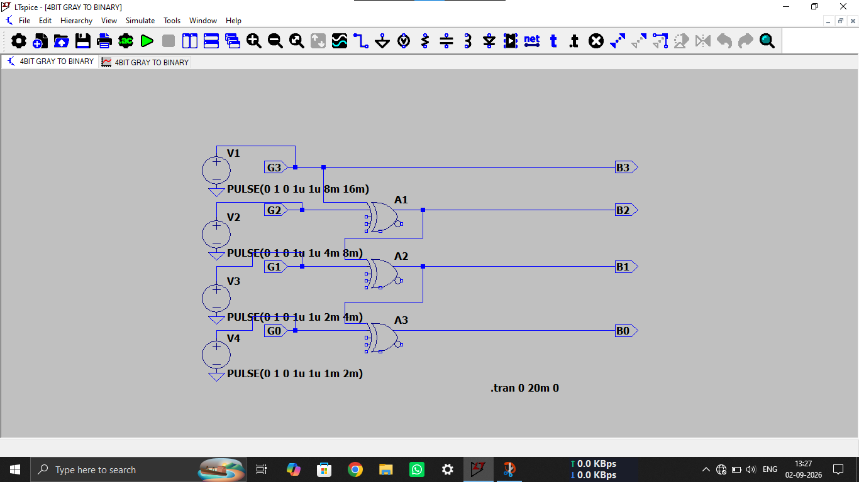
4-bit gray to binary code converter

LTSPICE SIMULATION OUTPUT:
